**FICCRISK-36975**

**Analysis- When there is no data for one/any VTD while generating the rates EOD limit check report**

Acceptance Criteria –

Scenario:  
In case of any VTD missing data or any VTD missing some measure data the report should be generated for rest of the VTD data and the alert should be sent for the missing measures.

Given:

* Currently EOD Limit Check report with subject "EOD limit based check" is reporting all the GLOBAL RATES VTD data for each limit.
* In case there is any measure missing for any VTD, alert is being generated with subject "CFTC Error][Action Required] MissingExposures:" .

When: The EOD Limit Check job is run from Bob monitor

Then:

1. The job should run, and email generated with subject "EOD limit based check" should report all GLOBAL RATES VTD data limit wise.  
2. The EOD Limit check job should run and if there is any measure missing/data missing for any VTD it should send an alert email with subject "[CFTC Error][Action Required] MissingExposures:"

Testing scenarios –

1. If there is any VTD which is missing some measures, the email should be triggered for missing exposure for that measure with subject- "[CFTC Error][Action Required] MissingExposures:" and one email for the data present for other measures of that VTD and data for other VTD's with subject -"EOD limit based check"
2. If there is no data for one whole VTD, that VTD should be shown in missing exposure email, and rest VTD's should come in "EOD limit based check" email.
3. The cc recipients for these emails is being picked up from eod_defaults.yaml
4. Verify that rest of the alert reports across CFTC are working fine, as part of regression.

Test Evidence –

/uat/core/remoterisk_services/cftc/uat_global_rates_eod_limits_check

Bob job ran:

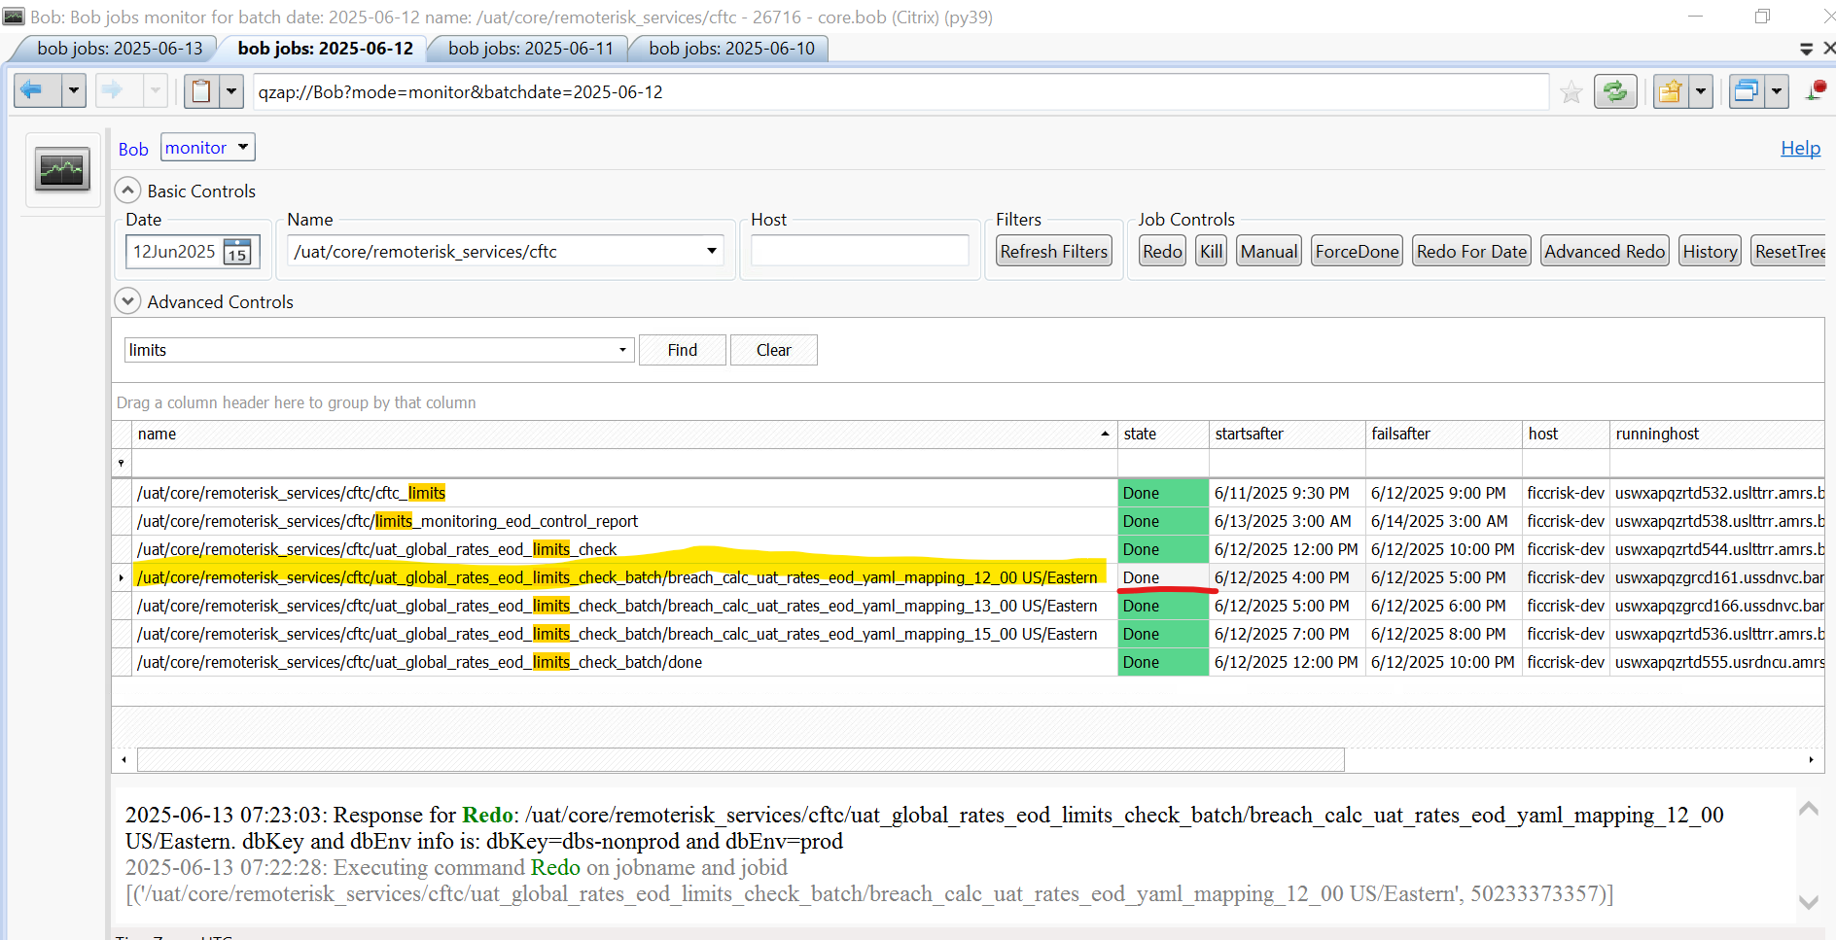

Eod limit based check report generated:

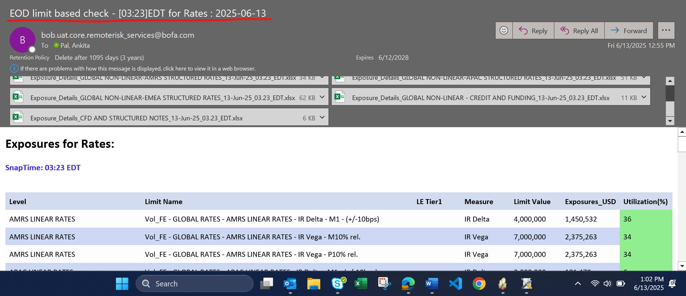

All VTDs covered in generated report and matching with eod_default.yaml script list:

AMRS Linear Rates

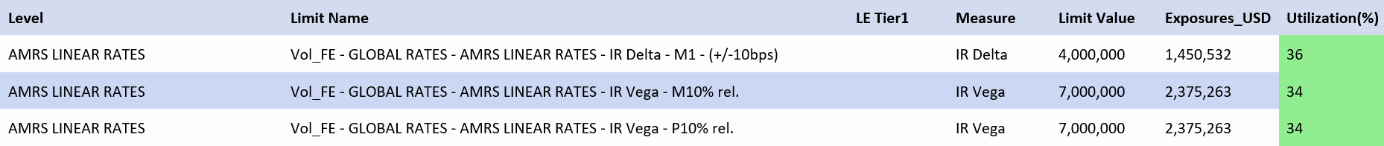

APAC Linear Rates



CFD & Structured Notes



EMEA Linear Rates

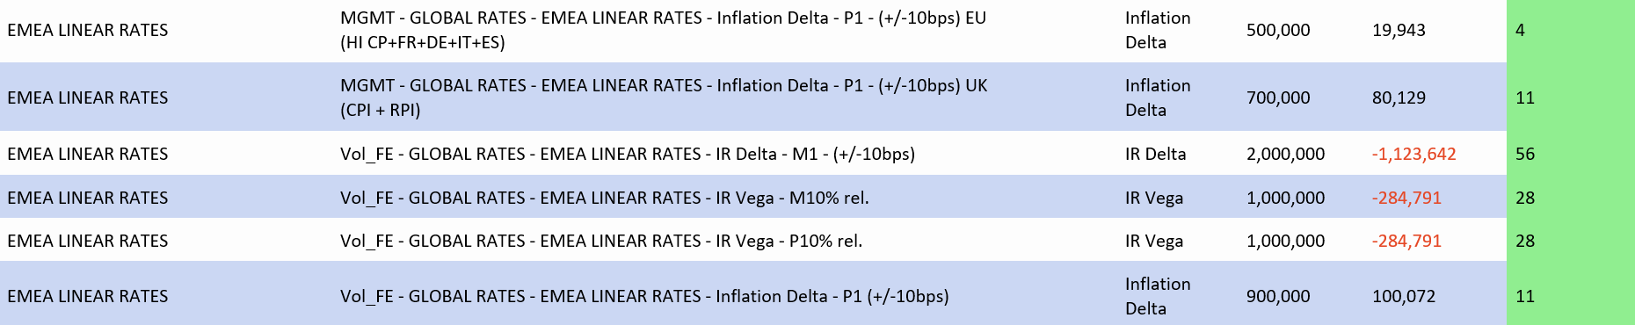

GNLR Credit and Funding



GNLR AMRS Structured Rates

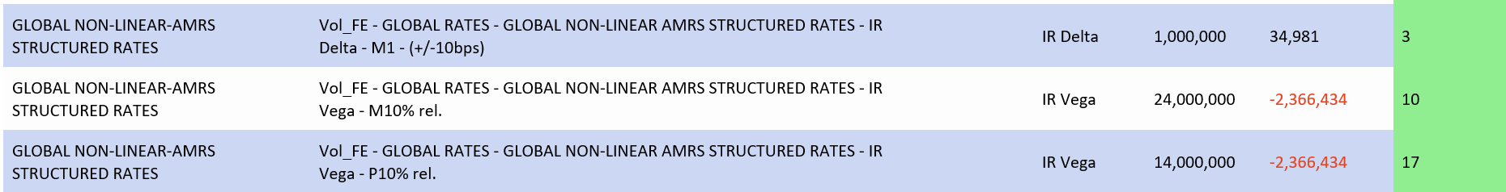

GNLR APAC Structured Notes

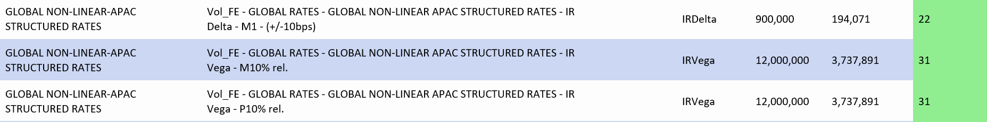

GNLR EMEA Structured Notes

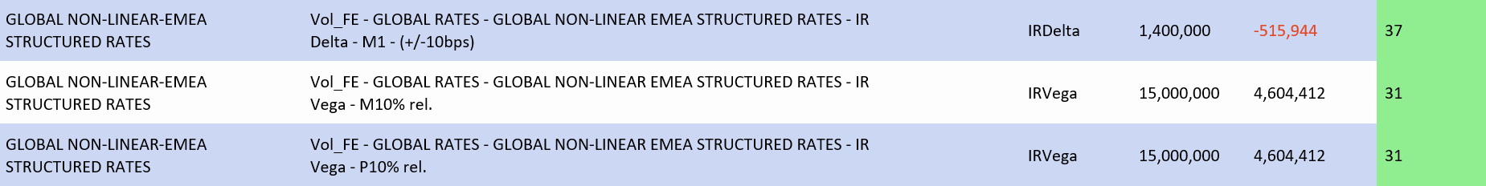

GLOBAL RATES

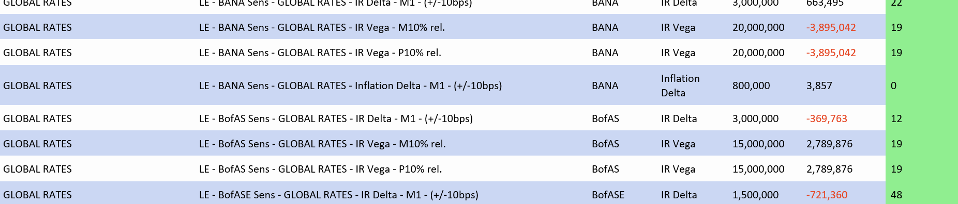

VTD List:

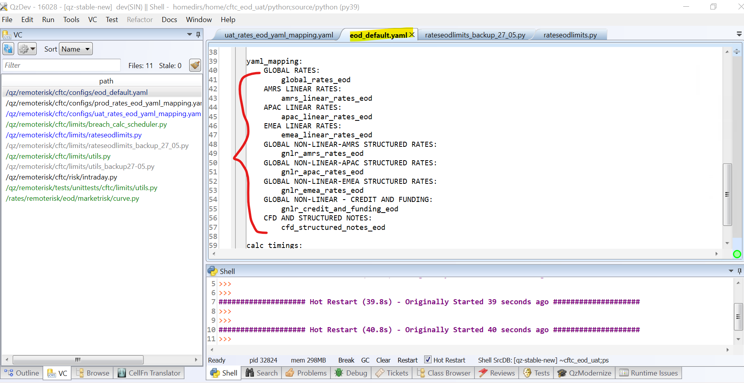

Action Required generated for measure with no data:

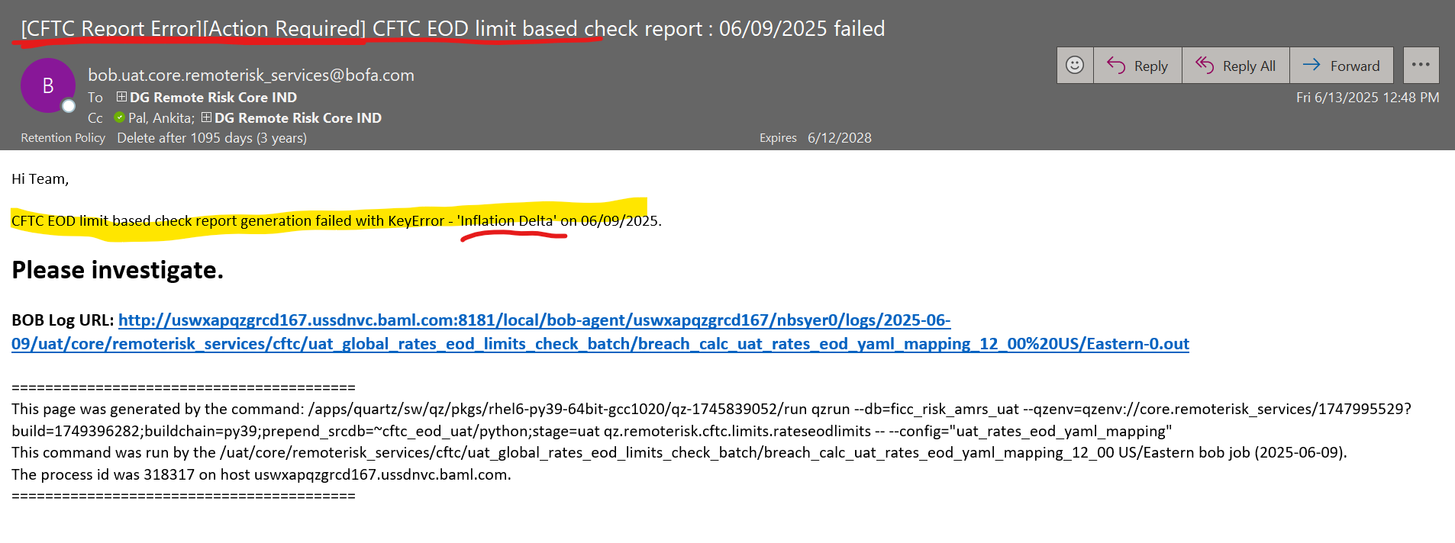

code snippet for testing can be added for any global rates VTD for testing after line 83 in rateseodlimits.py file-

(commented the lines mentioned down in the file in cftc_eod_uat staging area)

if name == 'CFD AND STRUCTURED NOTES':  
                    snapshotsForSource['IR01'] = qztable.Table(snapshotsForSource['IR01'].getSchema())  
                    snapshotsForSource['IR01'] = snapshotsForSource['IR01'].appendRow('FICC', 'GLOBAL RATES', 'CFD AND STRUCTURED NOTES', 'BKAC', 'STRUCTURED NOTES CIRO', 'QZ_NOTES.CU1O', 'USD', 12616.052)  
                    expTable = qztable.Table(expTable.getSchema())  
                    expTable = expTable.appendRow('FICC', 'GLOBAL RATES', 'CFD AND STRUCTURED NOTES', 'BKAC', 'STRUCTURED NOTES CIRO', 'QZ_NOTES.CU1O', 'USD', 12616.051904333124, 'IR01')  
                    fieldsDict =

{'source': 'management_rra', 'measure_names': ['Vega', 'IR01'], 'calc_level': ['VTD+Currency'], 'measuresMissingExposures': ['Vega'], 'level': 'CFD AND STRUCTURED NOTES'}

**Regression Testing:**

Limits Monitoring EOD Reports (Upload)

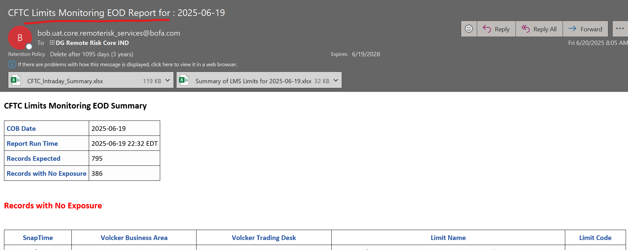

Breach calculator run and CFTC No Breach Report

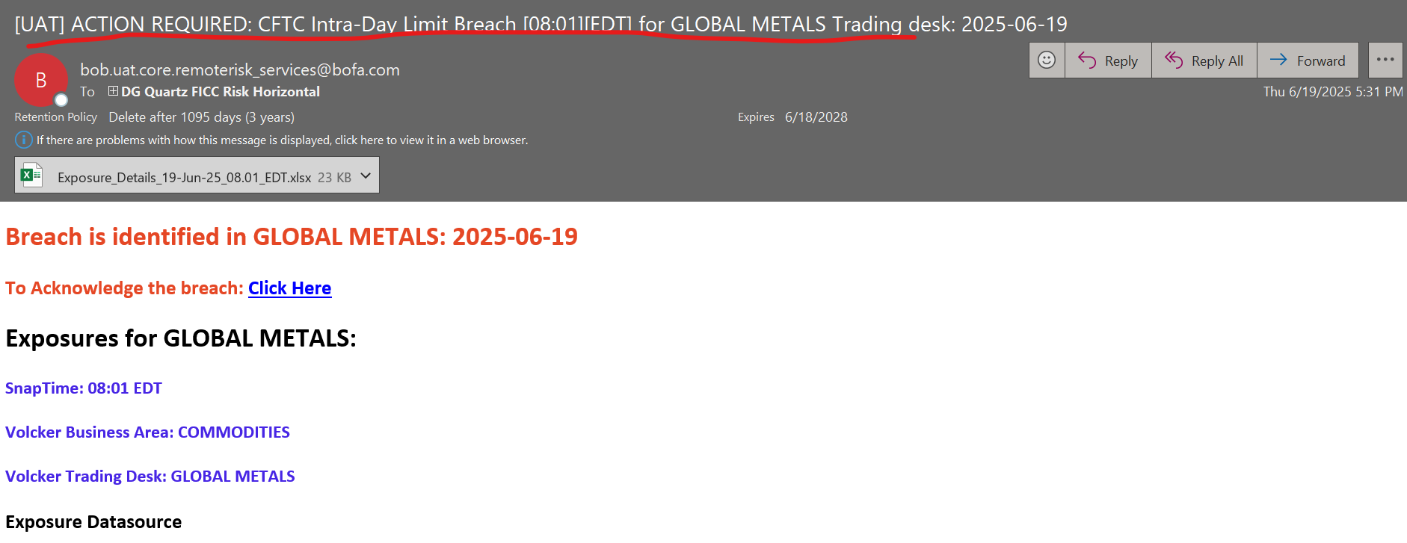

Limits Comparison Report

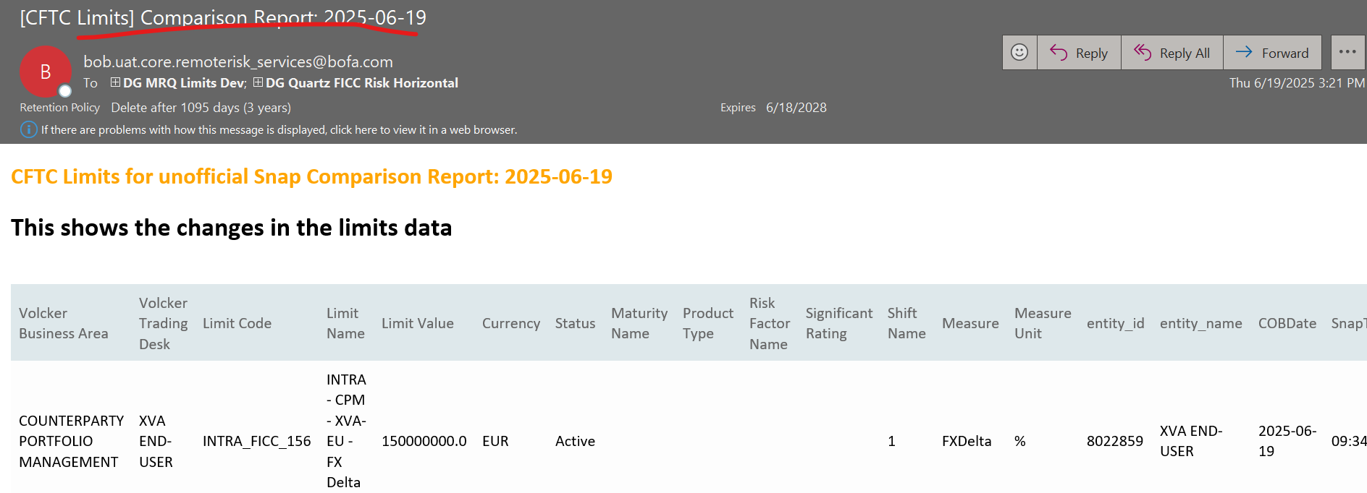

No Breach and missing exposures

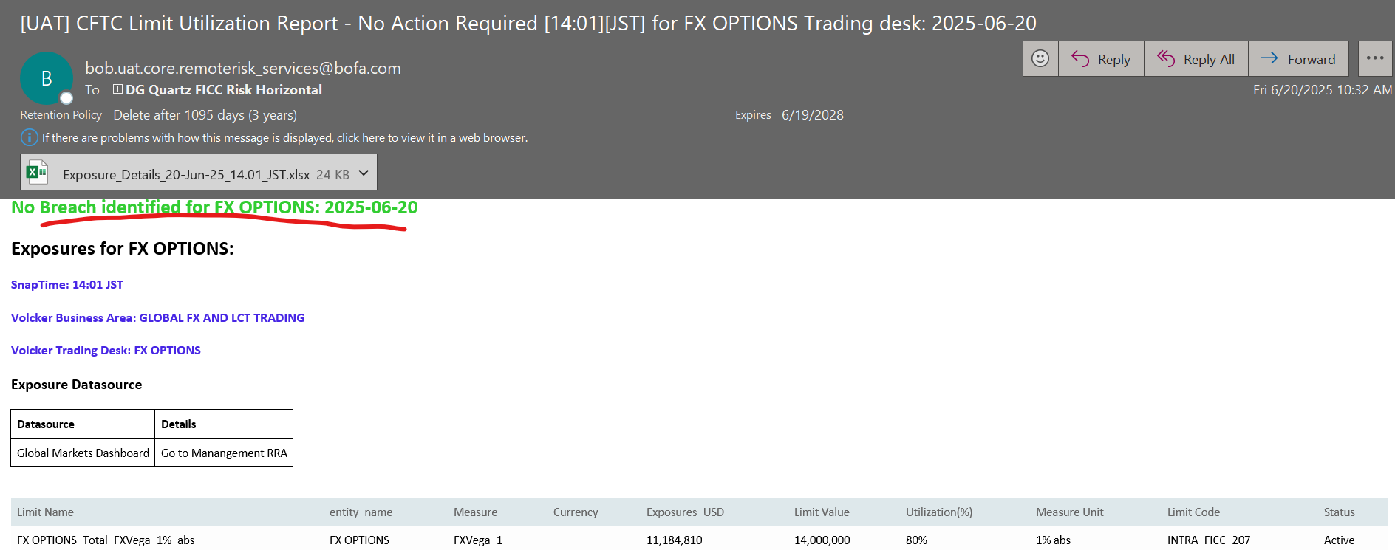

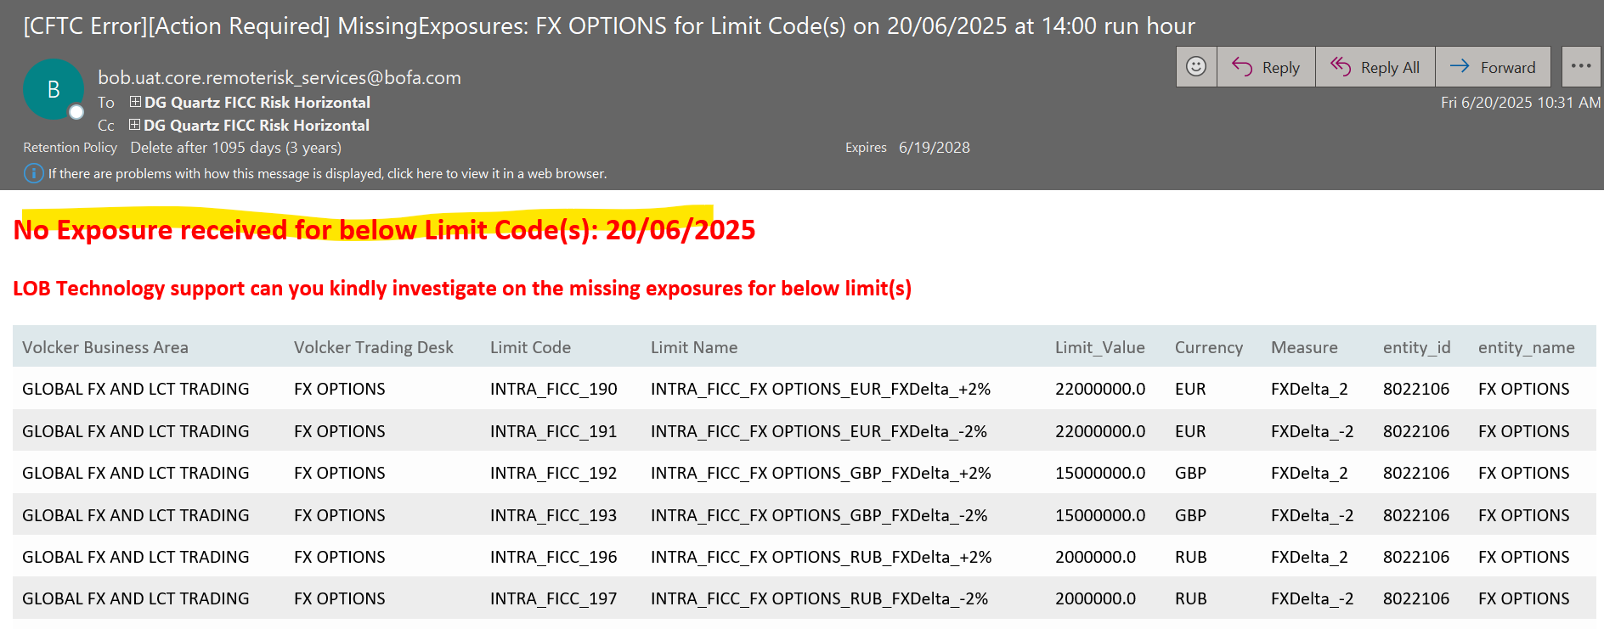

**7/9/2025**

**Replicating scenario of VTD data missing in PROD and UAT**

Putting breakpoint at line 83 (taking cob as 07/07/2025

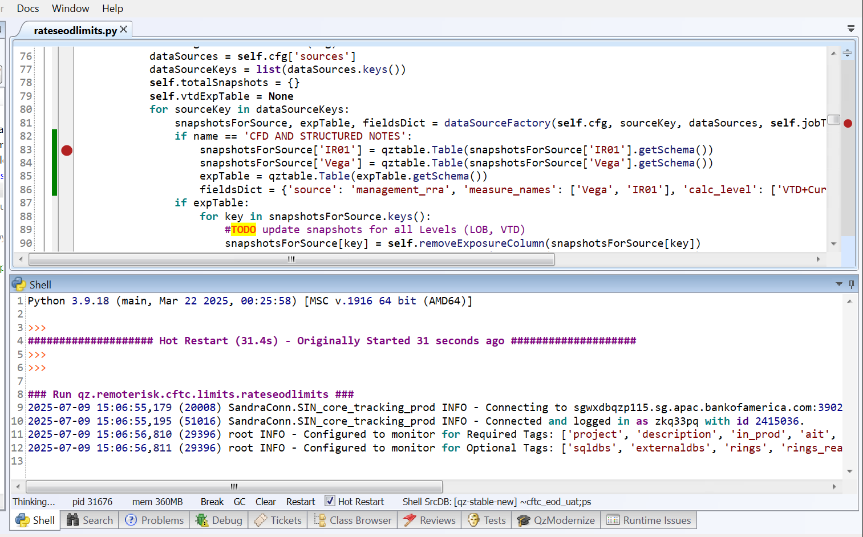

Printing expTable and we see CFD vtd data getting reflected

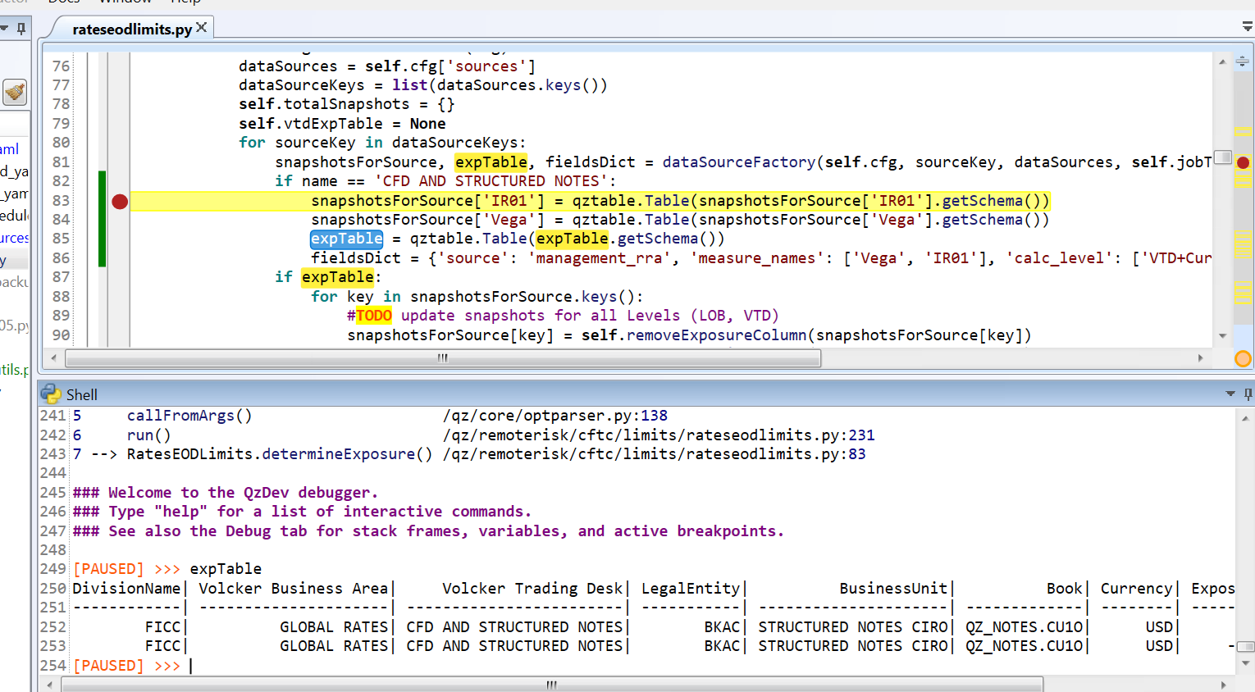

Doing f9 and also seeing table schema

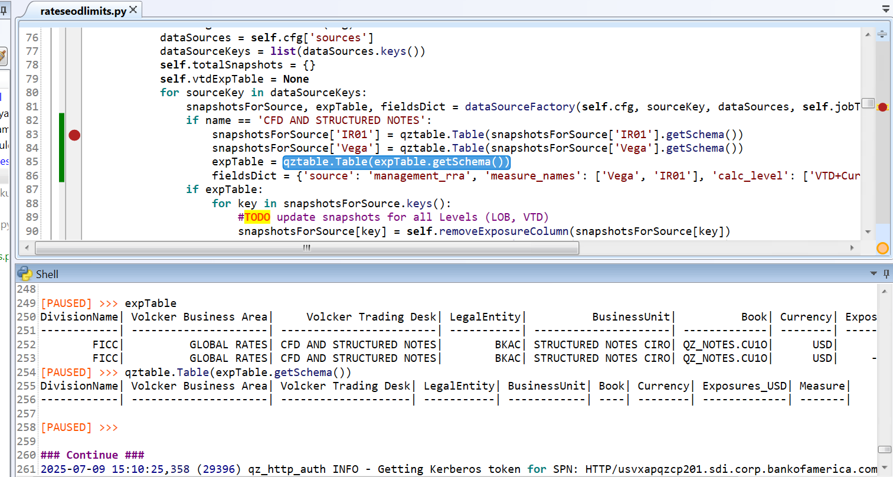

**EOD Limit Check report run post running script from area (Scenario 1 where NO DATA in one VTD)**

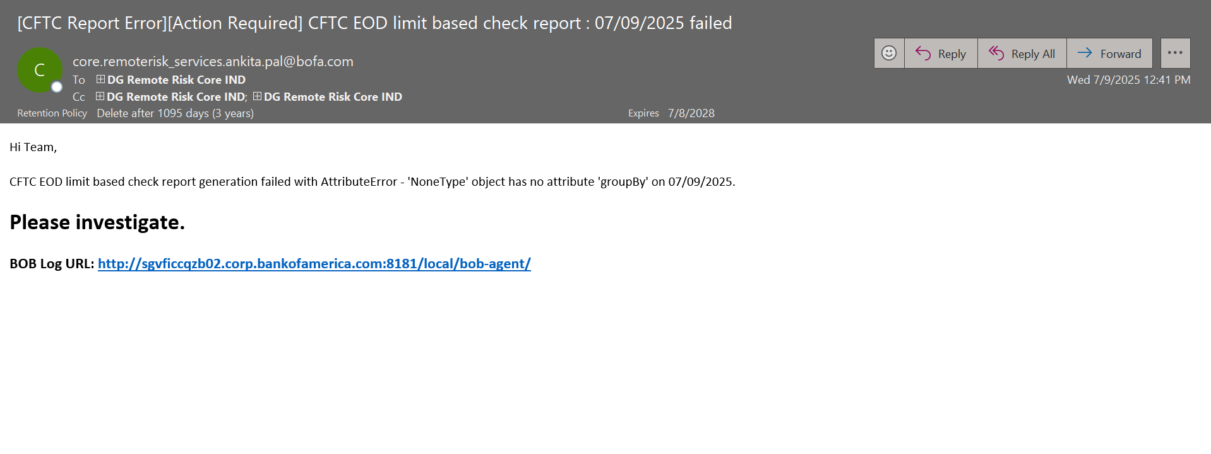

Debug point at line 82 gives all VTDs

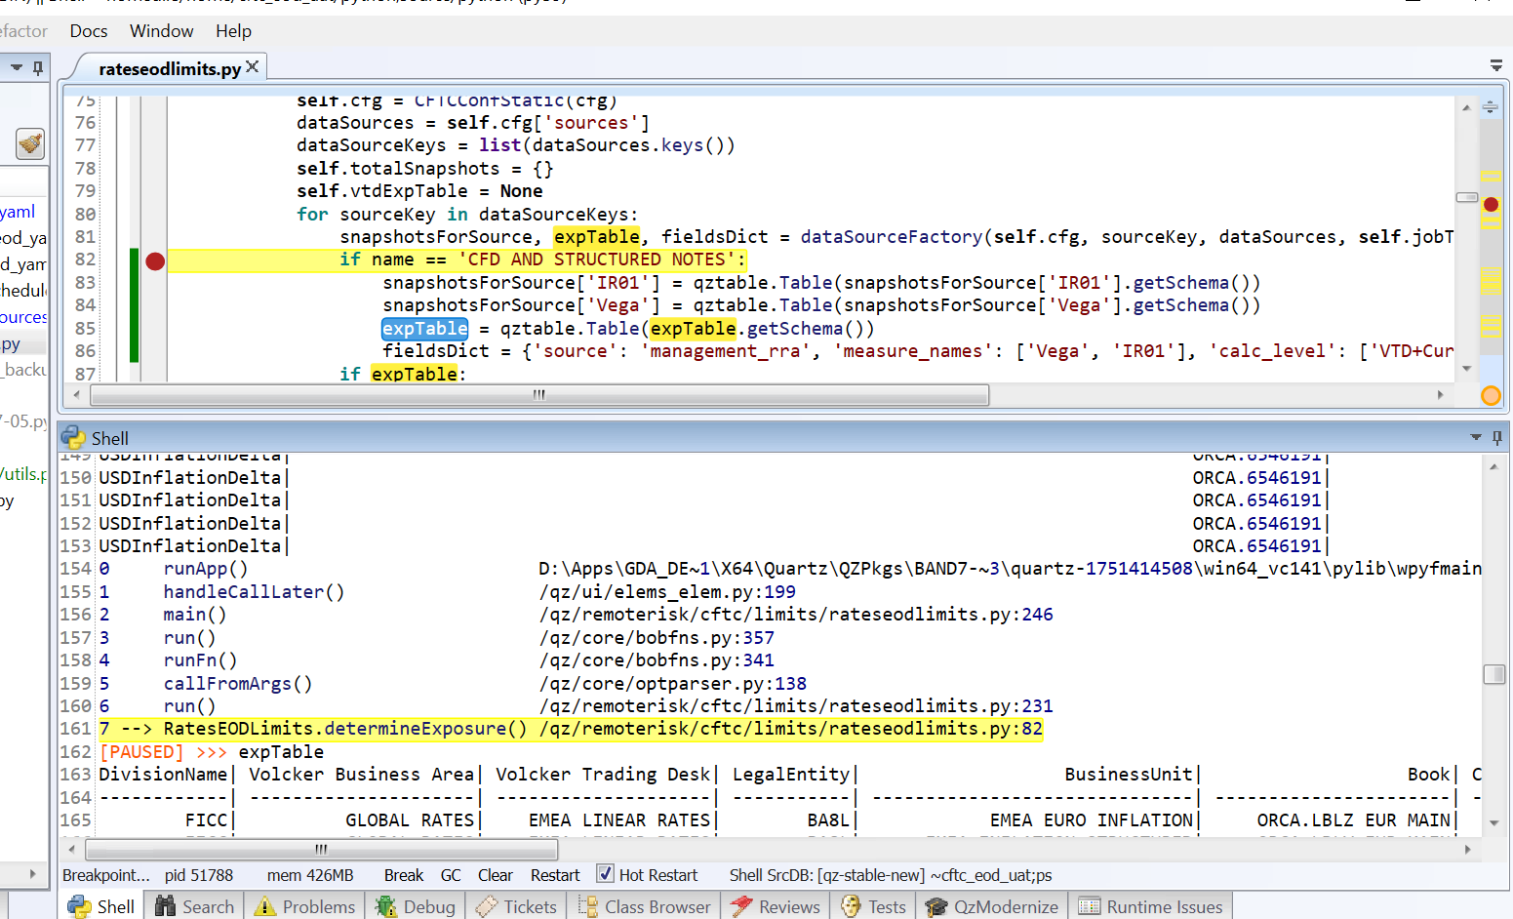

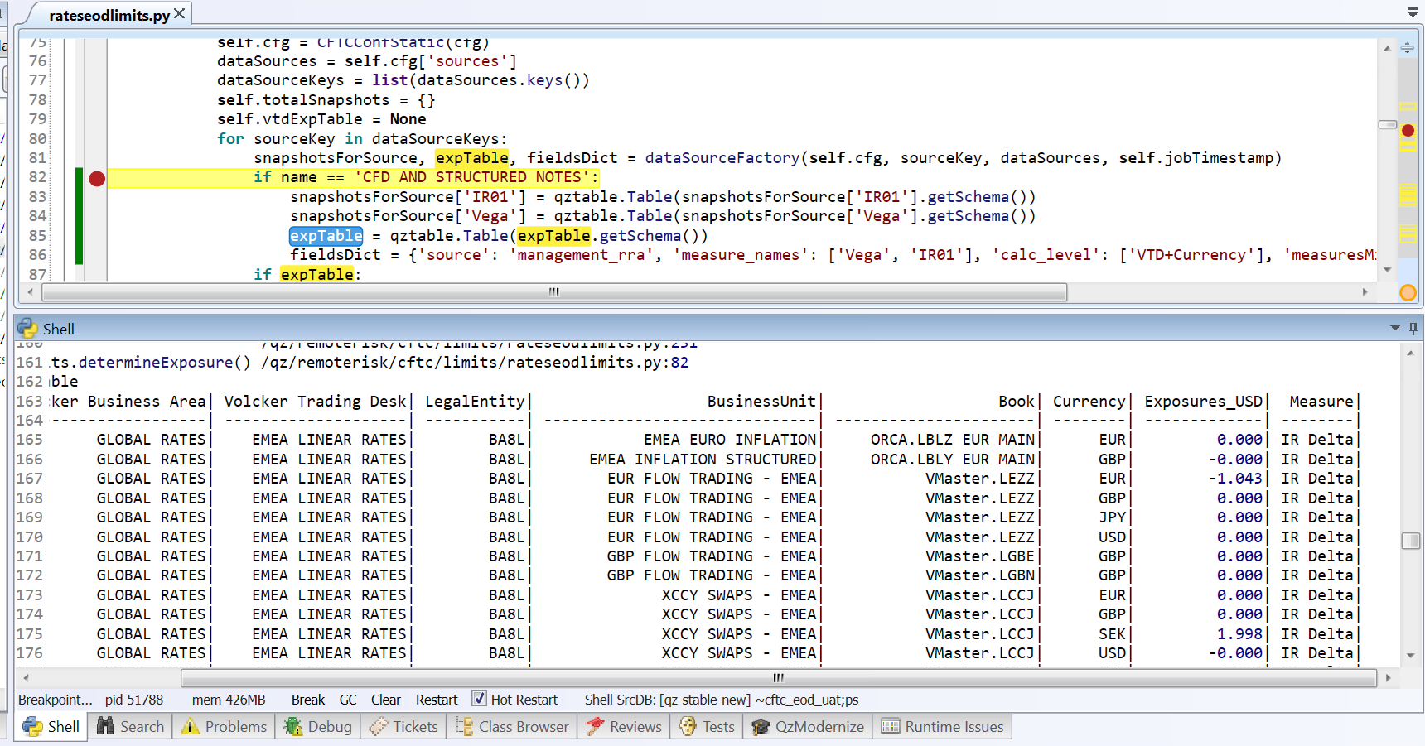

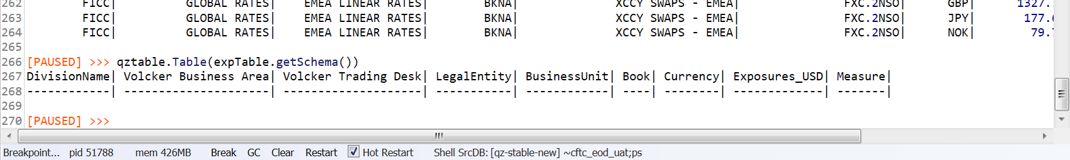

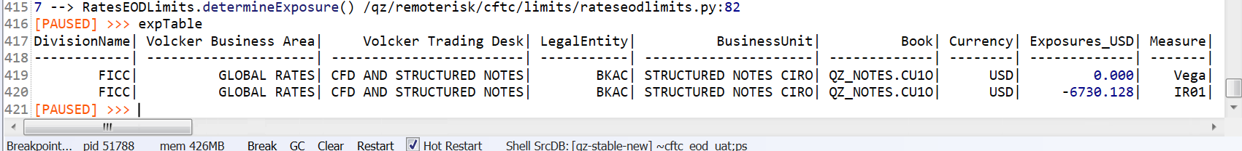

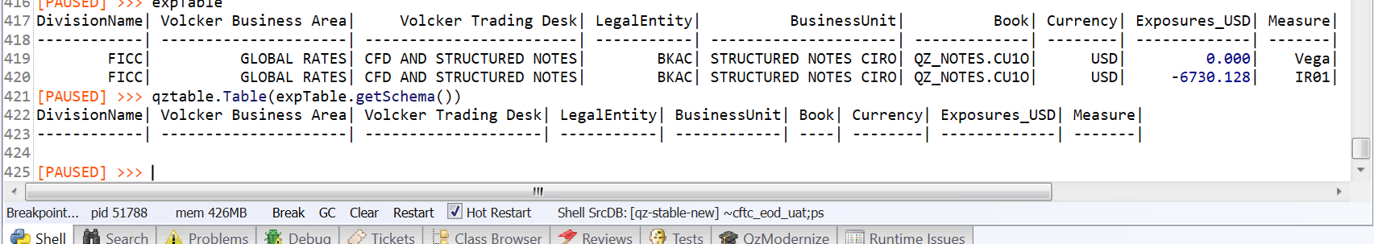

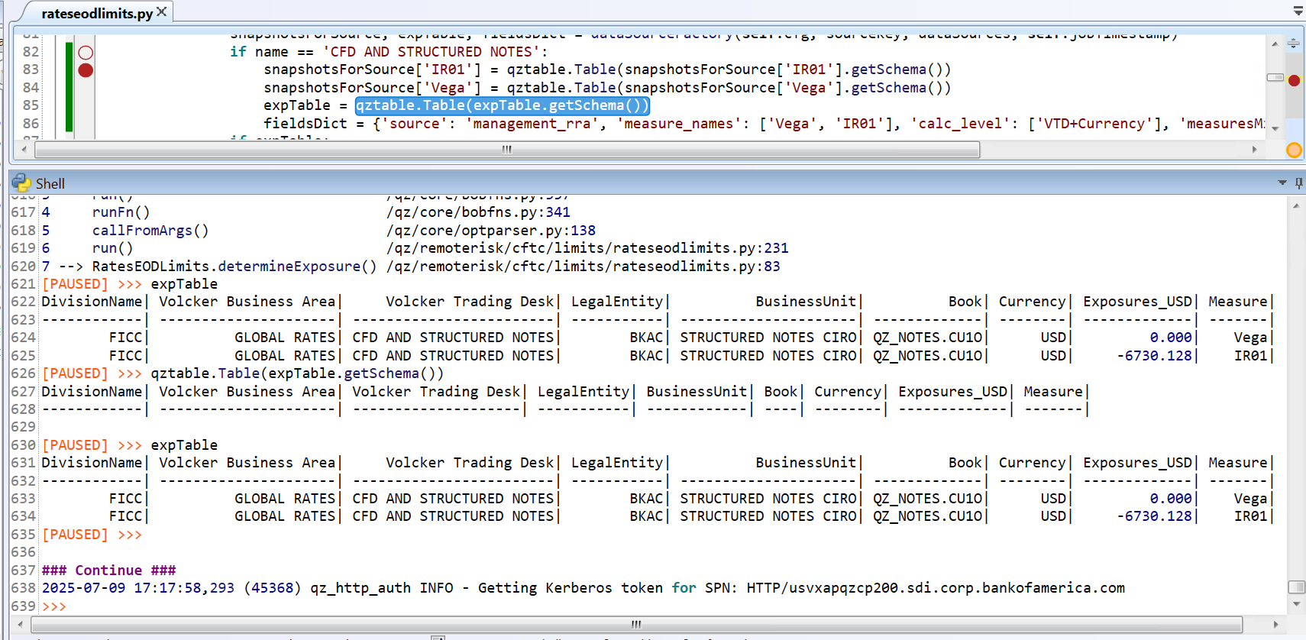

Need to check whether exposures missing getting generated for one measure not present and EOD limits check report with rest of the VTD

Code to see where one measure is available (IR01) but another is missing (Vega) for one VTD –

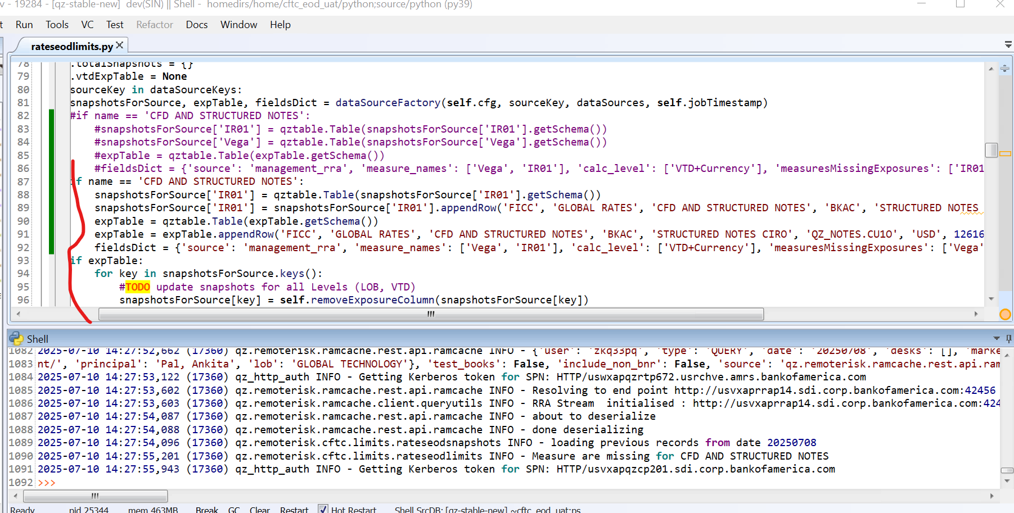

But report not generated, failing in UAT for this scenario (SCENARIO 2 where DATA in one measure present but other measure absent in one VTD)–

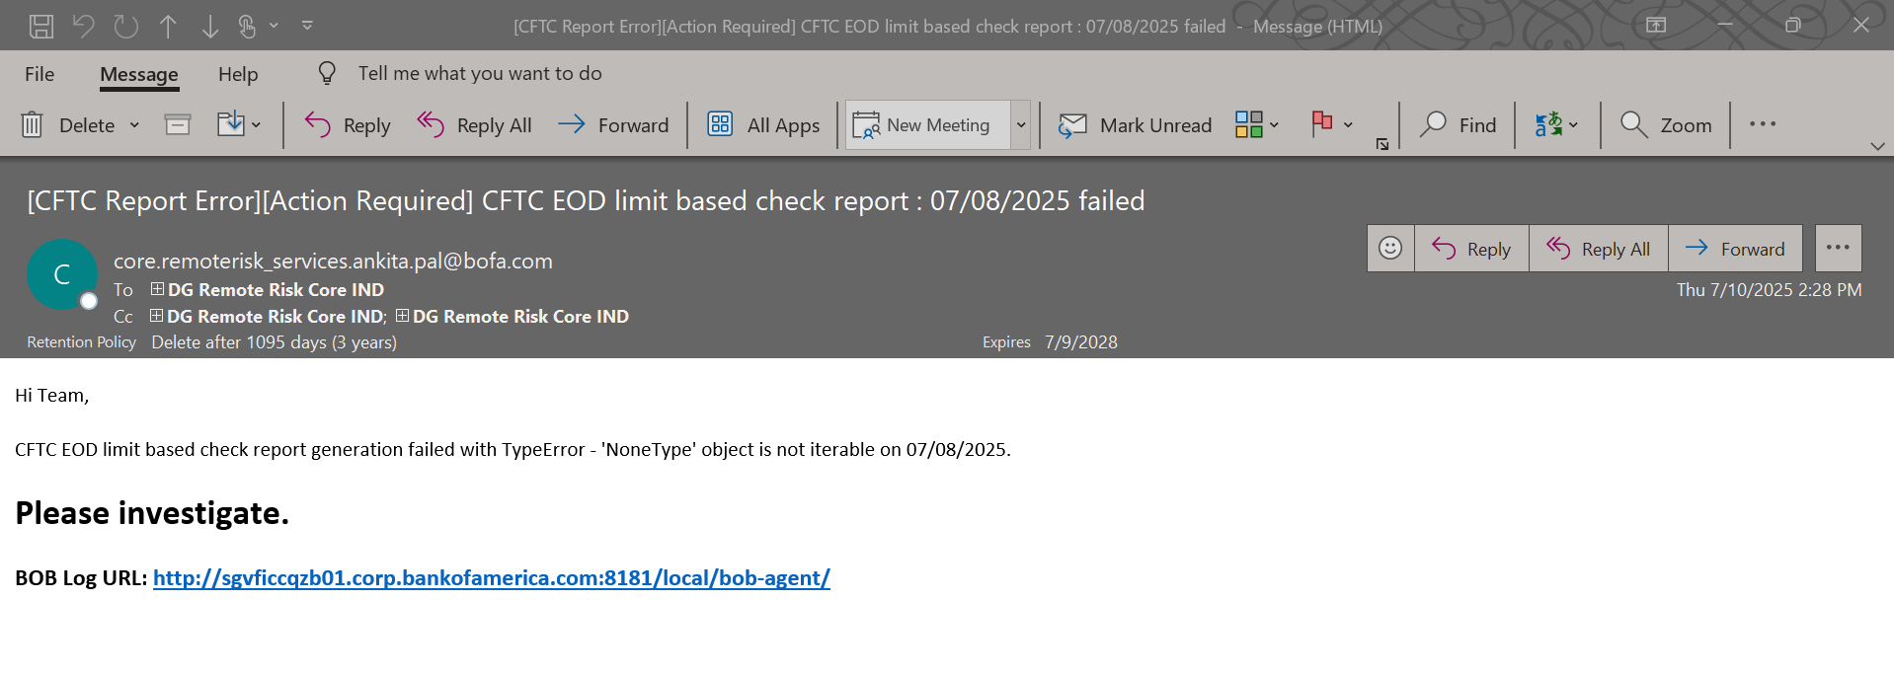

**SCENARIO 3 (WHERE ALL VTD DATA present) –**

